SR UNIVERSITY
Warangal, Telangana
School of Computer Science and Artificial Intelligence

A PROJECT REPORT ON
SpecScout – Mobile Specification Tracker

Data Analytics and Visualization (25CAI202PC201)

Submitted by
B. Sathwik (2503A52312)
T. HariswaraBrahmam (2503A52319)
A. Saiteja (2503A52318)

Under the guidance of
Dr. Neethu Prasad
Faculty Guide, School of CS & AI

Academic Year 2026–27

CERTIFICATE
This is to certify that the project report entitled “SpecScout – Mobile Specification Tracker” is a bonafide record of work carried out by B. Sathwik (2503A52312), T. HariswaraBrahmam (2503A52319), and A. Saiteja (2503A52318), in partial fulfilment of the requirements for the course Data Analytics and Visualization (25CAI202PC201) at the School of Computer Science and Artificial Intelligence, SR University, Warangal, during the academic year 2026–27, under my guidance.
The results presented in this report have not been submitted elsewhere for any other course or degree.
______________________________
Faculty Signature
Date: __________________
Place: Warangal

TABLE OF CONTENTS
Chapter | Title | Suggested section
1 | Project Goal | 1
2 | Data Overview | 2
3 | Data Cleaning Process | 3
4 | Data Analysis | 4
5 | Visualisation | 5
6 | Final Conclusion | 6
7 | Future Outcomes and Limitations | 7
Appendix | Code and Dashboard Evidence | 8

Note: Page numbers may shift slightly when the report is opened or edited in Microsoft Word. Update the table of contents if further content is added.

1. PROJECT GOAL

1.1 Problem Statement
The smartphone market contains many brands and models with different prices, ratings, memory capacities, battery sizes, display specifications, cameras, processors and network capabilities. Comparing these details manually can be time-consuming and makes it difficult for a buyer to identify models that match a preferred budget and specification range. SpecScout – Mobile Specification Tracker uses data analytics and an interactive Power BI dashboard to organise smartphone information and make comparison easier. The project analyses the available dataset and presents key patterns through summary measures, charts and filters.

1.2 Objectives
- Collect and organise smartphone specification data obtained from Kaggle.
- Clean and transform fields such as price, RAM, storage, battery capacity, display size and brand.
- Analyse smartphone prices, ratings, brands, price segments, memory capacities and 5G availability.
- Create visualisations that communicate important patterns in the smartphone dataset.
- Develop an interactive Power BI dashboard with filters and a detailed list of available smartphones.

1.3 Questions Addressed
- Which smartphone brands have the largest number of models in the dataset?
- How are smartphones distributed across budget, entry, mid-range, premium and ultra-premium price segments?
- What rating bands are most common?
- How are RAM and storage capacities distributed?
- What proportion of listed smartphones support 5G?
- Is there an observable relationship between smartphone price and rating?

2. DATA OVERVIEW

2.1 Data Source
The project dataset was obtained from Kaggle, as specified by the project team. The exact Kaggle dataset title, URL and access date were not included with the uploaded files; these details should be added before final submission.

2.2 Dataset Size and Structure
Dataset stage | Rows | Columns | Description
Uploaded raw Excel dataset | 1,074 | 11 | Original smartphone records with descriptive specification fields.
Uploaded fully cleaned CSV | 789 | 25 | Analytical dataset containing standardised and derived fields.

The raw Excel file contains 1,074 rows and 11 columns. The supplied fully cleaned CSV contains 789 rows and 25 columns. The dataset represents smartphone models and their listed specifications. No explicit observation date or historical time period is present in the supplied data.

2.3 Important Variables
Variable | Data type | Description
model | Text | Smartphone model name
brand | Text | Brand extracted/standardised from model name
price_inr | Integer | Price in Indian rupees
rating | Integer | Product rating score
price_segment | Category | Budget/entry/mid-range/premium/ultra-premium group
rating_band | Category | Grouped rating range
has_5g | Boolean | Whether 5G support is indicated
ram_gb | Numeric | RAM capacity in GB
storage_gb | Numeric | Internal storage in GB
battery_mah | Integer | Battery capacity in mAh
display_inches | Numeric | Display diagonal size in inches
resolution_width_px / resolution_height_px | Integer | Display resolution dimensions
os_family | Category | Operating system family

2.4 Target / Outcome Variable
This is an exploratory descriptive analytics project and does not use a predictive target variable. Price, rating, brand, RAM, storage, battery and 5G support are analysed as key descriptive fields.

2.5 Sample of Raw Data
model | price | rating | sim | processor | ram | battery | display | camera | card | os
Samsung Galaxy S26 Ultra | ₹1,59,990 | 95.0 | Dual Sim, 3G, 4G, 5G, VoLTE, Wi-Fi, NFC | Snapdragon 8 Elite Gen 5, Octa Core Processor | 12 GB RAM, 512 GB inbuilt | 5300 mAh Battery with 60W Fast Charging | 6.9 inches, 1440 x 3200 px, 120 Hz QHD+ OLED Display | 200 MP Quad Rear & 12 MP Front Camera | Memory Card Not Supported | Android v16
Samsung Galaxy S26+ | ₹94,999 | 92.0 | Dual Sim, 3G, 4G, 5G, VoLTE, Wi-Fi, NFC | Snapdragon 8 Elite Gen 5, Octa Core Processor | 12 GB RAM, 256 GB inbuilt | 4900 mAh Battery with Fast Charging | 6.7 inches, 1440 x 3120 px, 120 Hz QHD+ OLED Display | 50 MP Triple Rear & 12 MP Front Camera | Memory Card Not Supported | Android v16
Samsung Galaxy S26 | ₹84,999 | 90.0 | Dual Sim, 3G, 4G, 5G, VoLTE, Wi-Fi, NFC | Snapdragon 8 Elite Gen 5, Octa Core Processor | 12 GB RAM, 256 GB inbuilt | 4300 mAh Battery with Fast Charging | 6.3 inches, 1440 x 3120 px, 120 Hz QHD+ OLED Display | 50 MP + 50 MP + 12 MP Triple Rear & 12 MP Front Camera | Memory Card Not Supported | Android v16
Apple iPhone 18 Pro | ₹1,29,900 | 96.0 | Dual Sim, 3G, 4G, 5G, VoLTE, Wi-Fi, NFC | Apple A20, Hexa Core Processor | 12 GB RAM, 256 GB inbuilt | 4000 mAh Battery with Fast Charging | 6.3 inches, 1179 x 2556 px, 120 Hz OLED Display | 48 MP Triple Rear & 12 MP Front Camera | Memory Card Not Supported | iOS v20
OnePlus 16 | ₹89,990 | 93.0 | Dual Sim, 3G, 4G, 5G, VoLTE, Wi-Fi, NFC | Next-gen Snapdragon flagship, Octa Core | 12 GB RAM, 256 GB inbuilt | 7500 mAh Battery with Fast Charging | 6.82 inches, 1440 x 3168 px, 165 Hz LTPO AMOLED Display | 50 MP + 50 MP + 50 MP Triple Rear & 32 MP Front Camera | Memory Card Not Supported | Android v16

Table 2.2: First five records from the uploaded raw Excel dataset.

3. DATA CLEANING PROCESS

3.1 Initial Data Quality
Raw column | Missing values
rating | 141
camera | 1
card | 7
os | 17

The raw file contains 166 missing cells. Missing values occur mainly in rating (141), operating system (17), card support (7) and camera (1). The uploaded cleaned CSV has no missing values.

3.2 Transformations Visible in the Supplied Cleaning Script
- The raw Excel file is loaded with pandas using the first worksheet.
- The price field is converted to a numeric helper field by removing the rupee symbol and comma separators.
- Regular expressions are used to extract RAM values expressed in GB or MB.
- Storage capacity is extracted from the RAM/specification text in GB, MB or TB and converted to GB.
- Battery capacity is extracted from text containing the mAh unit.
- The brand field is derived from the first word of the smartphone model name.
- The transformed data is exported to a CSV file.

3.3 Before-and-After Dataset Size
Measure | Raw dataset | Uploaded cleaned dataset
Rows | 1,074 | 789
Columns | 11 | <docx.text.paragraph.Paragraph object at 0x7f33596b05e0>
Duplicate rows | 0 | 0
Missing cells | 166 | 0

The uploaded cleaned CSV has 285 fewer rows than the raw Excel file, a reduction of 26.54%. However, the supplied cleaning script does not show a row-filtering step that explains this reduction, and its output filename differs from the uploaded fully cleaned CSV. Therefore, the exact reason for the row reduction and the exact treatment of each missing raw value cannot be verified from the supplied script alone. This should be checked with the project team before submission.

3.4 Data Types and Feature Engineering
The fully cleaned dataset stores price, rating, RAM, storage, battery and display size in numeric formats, and stores has_5g as a Boolean field. Additional analytical fields include price_segment, rating_band, resolution dimensions, refresh_rate, memory_card_type, memory_card_max_capacity and os_family.

3.5 Outliers and Limitations in Cleaning Evidence
The cleaned data includes very high listed prices and unusually large battery values. These may represent specialised or rugged devices, premium models, or source-data anomalies. The supplied scripts do not document an outlier-removal procedure, so these values have been retained in the descriptive analysis. Extreme values can influence the arithmetic mean; the median is therefore also reported where useful.
Tools visible in the supplied scripts include Python, pandas, NumPy and regular expressions. The visualisation script uses Matplotlib. Power BI is used for the interactive dashboard.

4. DATA ANALYSIS

4.1 Descriptive Statistics
Metric | Value
Total smartphone records | 789
Unique brands | 42
Average price | ₹27,869.48
Median price | ₹16,999
Minimum price | ₹1,999
Maximum price | ₹650,000
Average rating | 77.62
Median rating | 79
Average RAM | 6.06 GB
Average storage | 129.72 GB
Average battery | 4,877 mAh
Average display size | 6.50 inches

The dashboard screenshot displays rounded KPI values of average price ₹27.87K, average rating 77.62, average RAM 6.06 GB and total phones 789. These align with the supplied cleaned dataset.

4.2 Brand Representation
Brand | Models | Share of cleaned dataset
Samsung | 122 | 15.5%
Xiaomi | 103 | 13.1%
vivo | 95 | 12.0%
realme | 87 | 11.0%
OPPO | 64 | 8.1%
Motorola | 40 | 5.1%
POCO | 38 | 4.8%
Apple | 36 | 4.6%
Infinix | 30 | 3.8%
OnePlus | 27 | 3.4%

Samsung has the largest representation with 122 models, followed by Xiaomi (103) and vivo (95). The dataset contains 42 distinct brands.

4.3 Price Segment Distribution
Price segment | Models | Share
Entry (₹10K–₹20K) | 368 | 46.6%
Mid-range (₹20K–₹40K) | 173 | 21.9%
Budget (≤₹10K) | 137 | 17.4%
Ultra-premium (>₹70K) | 63 | 8.0%
Premium (₹40K–₹70K) | 48 | 6.1%

The Entry segment (₹10,000–₹20,000) is the largest group, representing 46.6% of the cleaned dataset. Mid-range models account for 21.9%, while the budget segment accounts for 17.4%. Premium and ultra-premium models together make up a smaller portion of the available records.

4.4 Rating, 5G and Memory Patterns
The most common rating band is 80–89, with 366 models (46.4%). A further 35.9% are in the 70–79 band. The dataset records 380 5G-capable phones (48.2%) and 409 phones without 5G support (51.8%).
RAM capacities of 8 GB, 6 GB and 4 GB are the three most frequent groups (224, 220 and 205 models respectively). 128 GB is the most common storage capacity, appearing in 416 models (52.7%).

4.5 Relationship Between Price and Rating
The Pearson correlation between price and rating is 0.275, indicating a weak-to-moderate positive association in this dataset. This means higher-priced models tend to have somewhat higher ratings on average, but price alone does not determine rating. Correlation does not establish causation.

4.6 Key Findings
- The cleaned dataset contains 789 smartphone records from 42 brands.
- Samsung, Xiaomi and vivo are the three most represented brands.
- Entry-priced smartphones form the largest price segment.
- Ratings of 80–89 are the most common rating band.
- 8 GB, 6 GB and 4 GB are the most frequent RAM capacities; 128 GB is the most common storage capacity.
- 5G support is present in 48.2% of the records.
- Price and rating show a positive but not strong linear relationship.

5. VISUALISATION
The following figures were generated from the uploaded fully cleaned CSV for this report. The final Power BI dashboard screenshots supplied by the project team are included after the analytical figures.
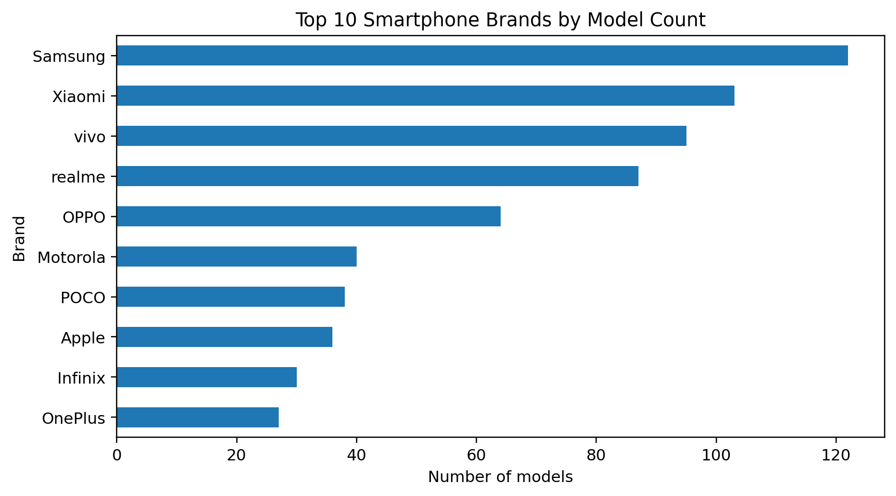
Figure 5.1: Top 10 Smartphone Brands by Model Count
The horizontal bar chart compares the number of smartphone models available for the ten most represented brands.
Conclusion: Samsung leads the dataset, followed by Xiaomi and vivo. This indicates that the dataset has stronger representation for these brands than for the remaining brands.
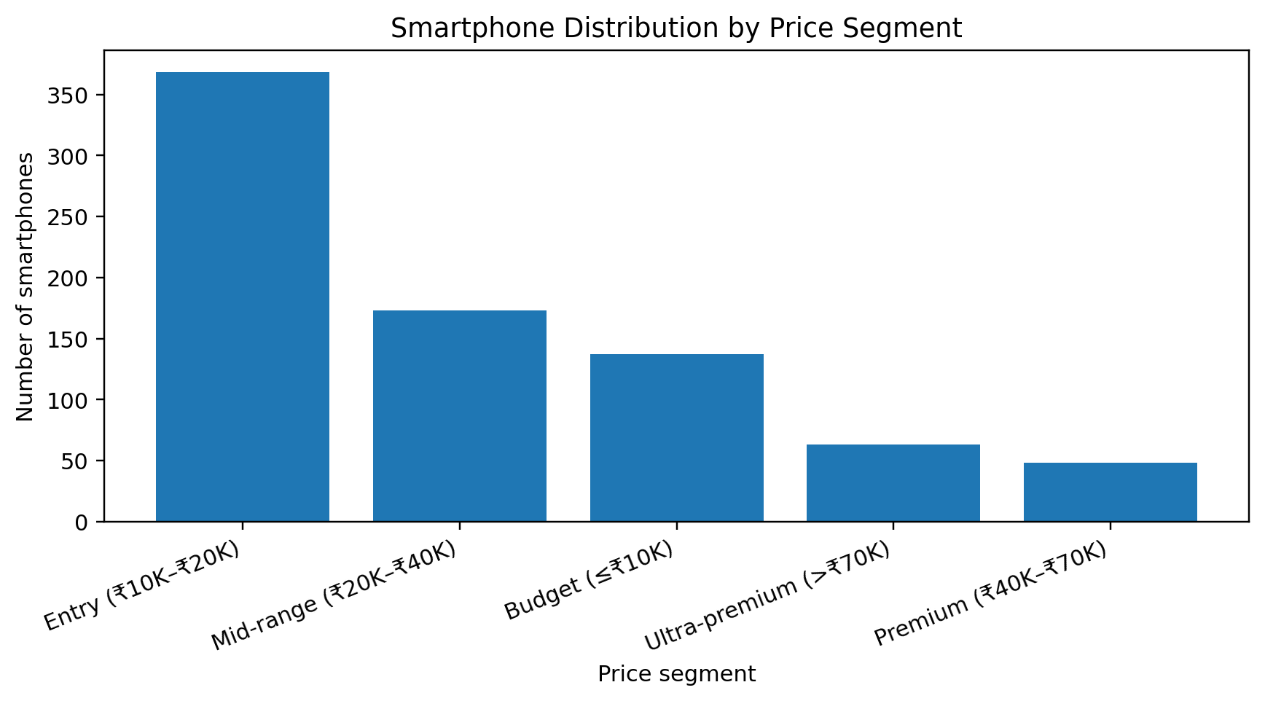
Figure 5.2: Smartphone Distribution by Price Segment
The chart groups phones into budget, entry, mid-range, premium and ultra-premium price categories.
Conclusion: The entry segment is the largest category, showing that the dataset is concentrated around smartphones priced between ₹10,000 and ₹20,000.
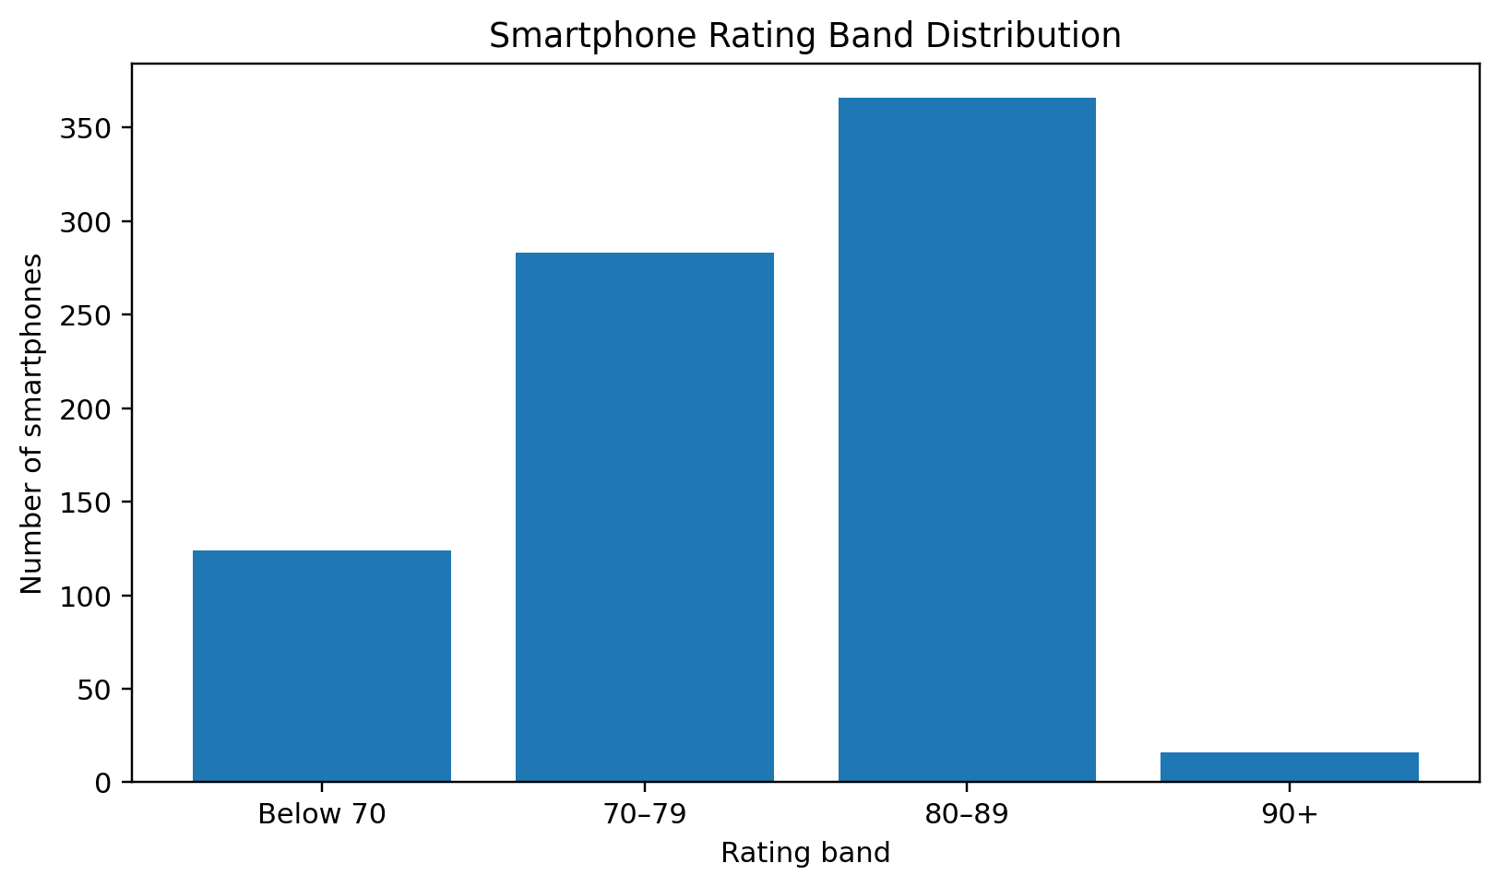
Figure 5.3: Smartphone Rating Band Distribution
The bar chart shows how many models fall into each rating range.
Conclusion: The 80–89 band contains the largest number of models. Only a small proportion of records have ratings of 90 or above.
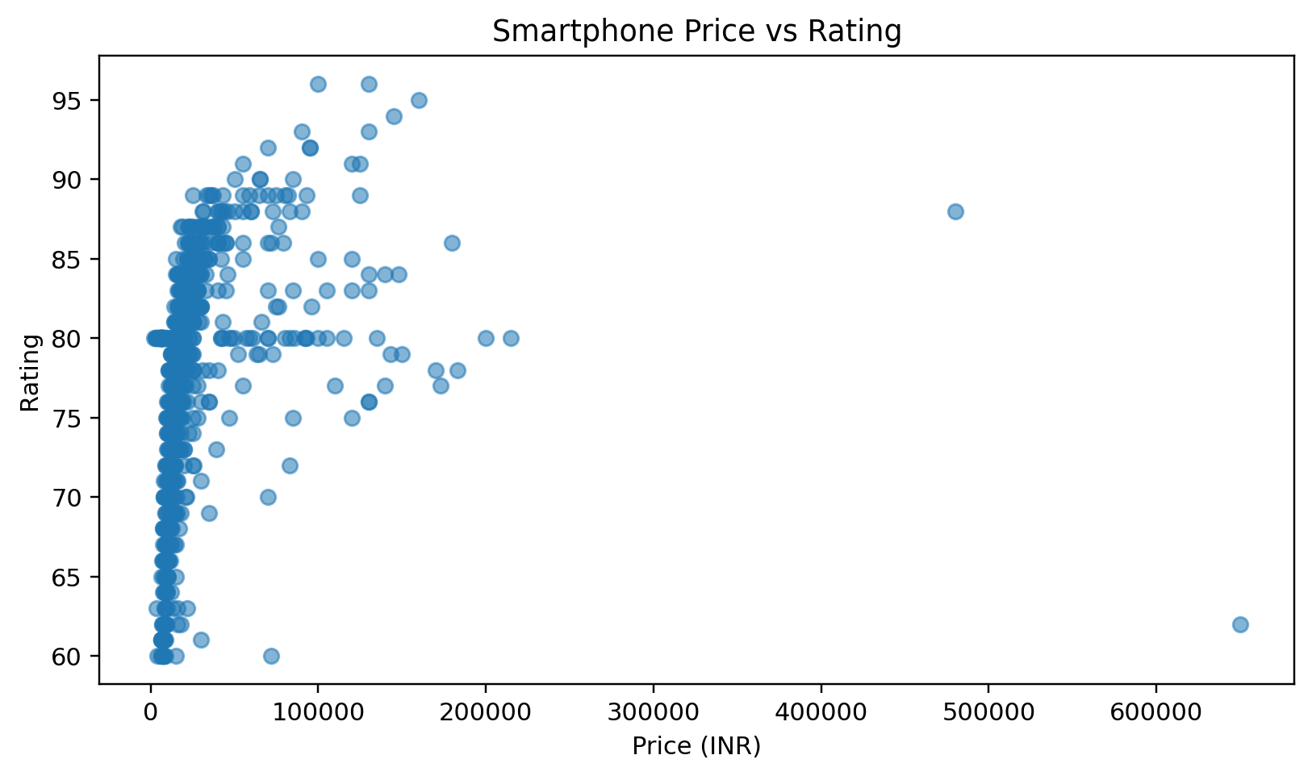
Figure 5.4: Smartphone Price vs Rating
The scatter plot compares listed price in INR with the rating score for each smartphone.
Conclusion: The points show a broad spread of ratings at different prices. The calculated correlation (0.275) suggests only a modest positive association, so price should not be treated as a substitute for rating.
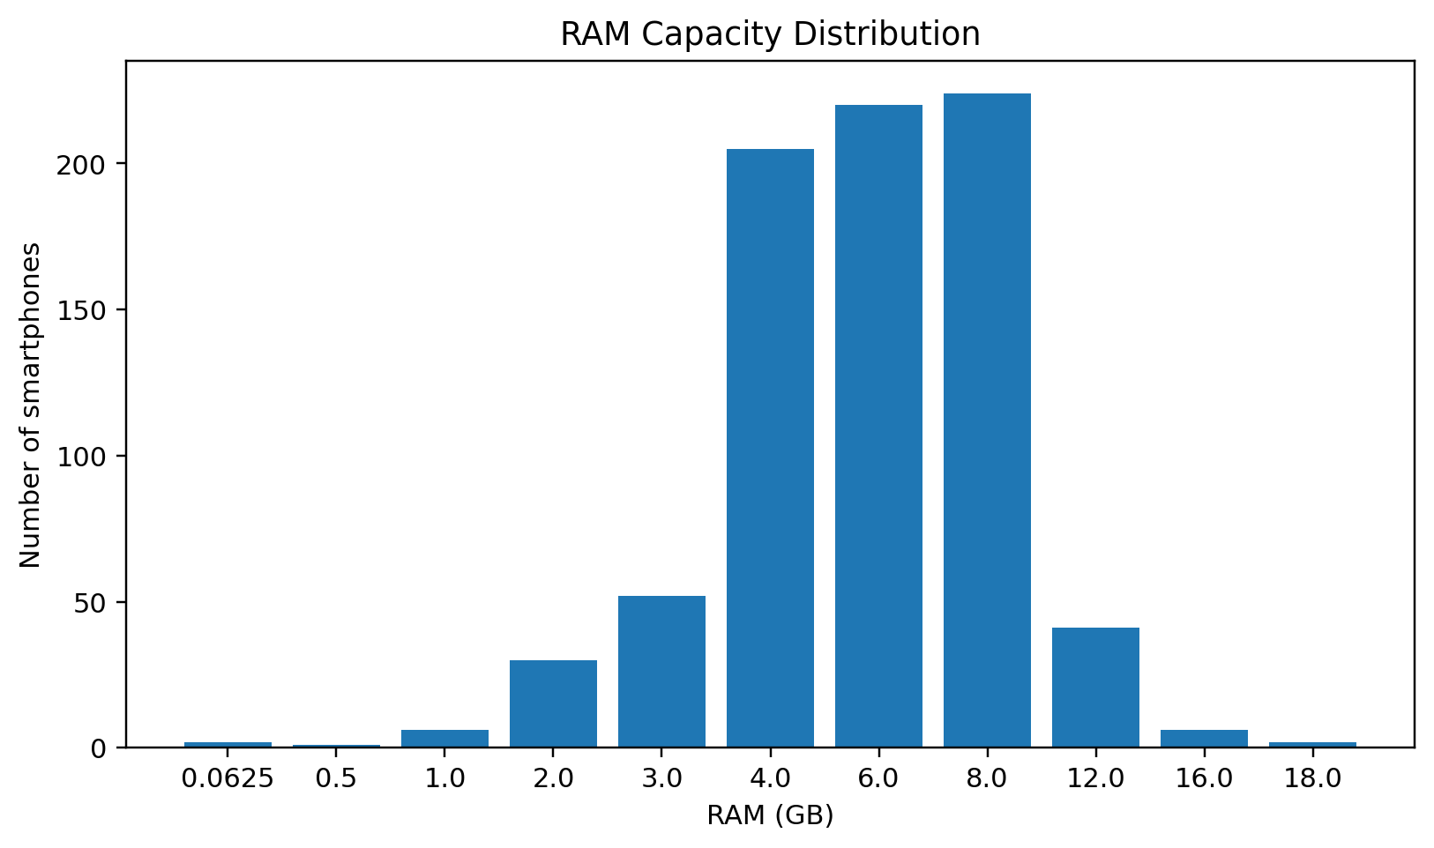
Figure 5.5: RAM Capacity Distribution
The chart compares the number of models at each extracted RAM capacity in GB.
Conclusion: The 8 GB, 6 GB and 4 GB categories dominate the records. This gives users a quick view of the most common memory configurations in the dataset.
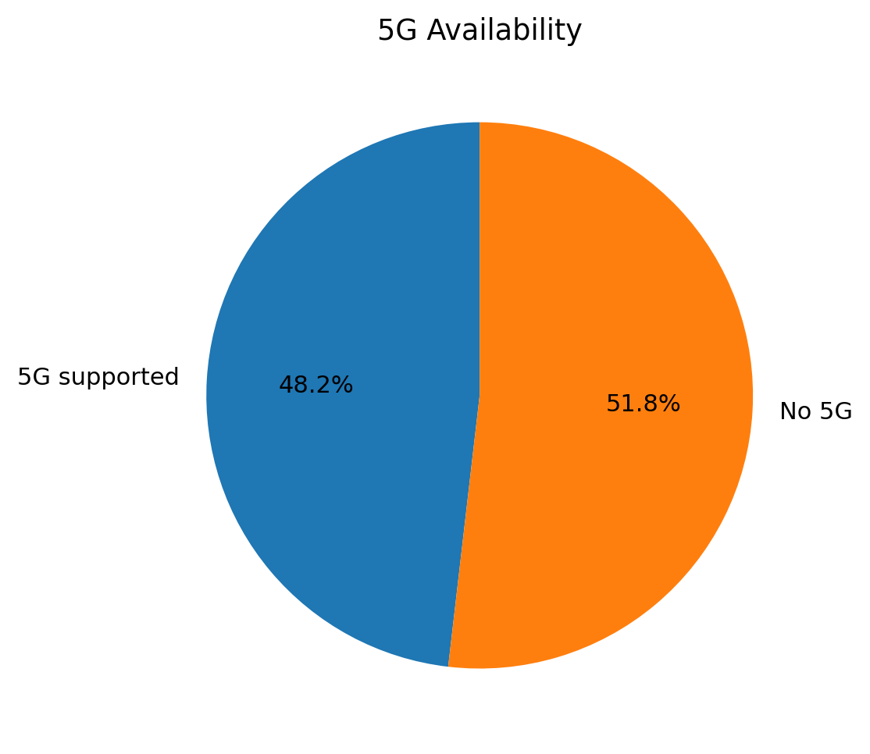
Figure 5.6: 5G Availability
The pie chart displays the proportion of records marked as 5G-supported and not 5G-supported.
Conclusion: The two groups are relatively balanced, with 48.2% marked as 5G-supported and 51.8% marked as not 5G-supported.

5.7 Power BI Dashboard
The Power BI dashboard combines KPI cards, slicers, comparison charts and a smartphone listing page. The main page includes filters for display size, battery capacity, price, RAM, storage and rating, along with brand, price-segment and camera dropdown filters. KPI cards show average price, average rating, average RAM and total phone count. Charts show average price by model, price versus rating, price per RAM, price-segment distribution and model count by brand.
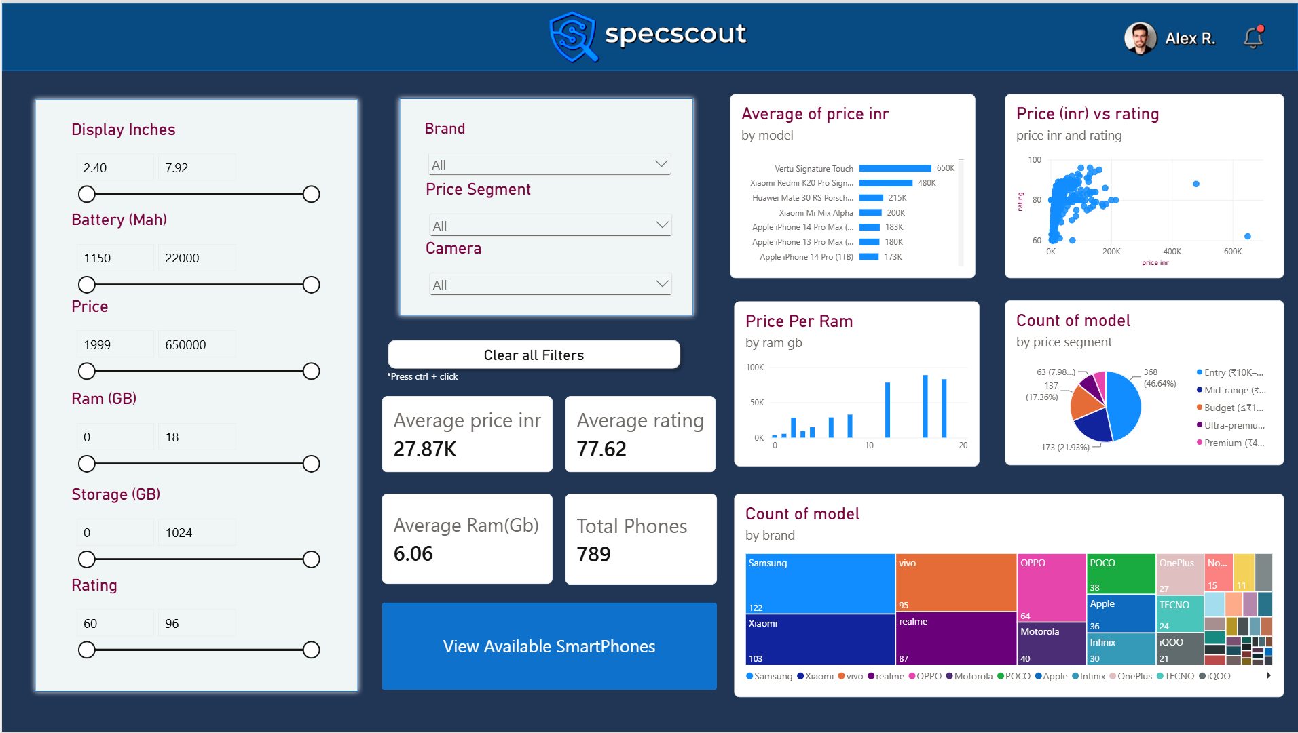
Figure 5.7: SpecScout Power BI overview dashboard supplied by the project team.
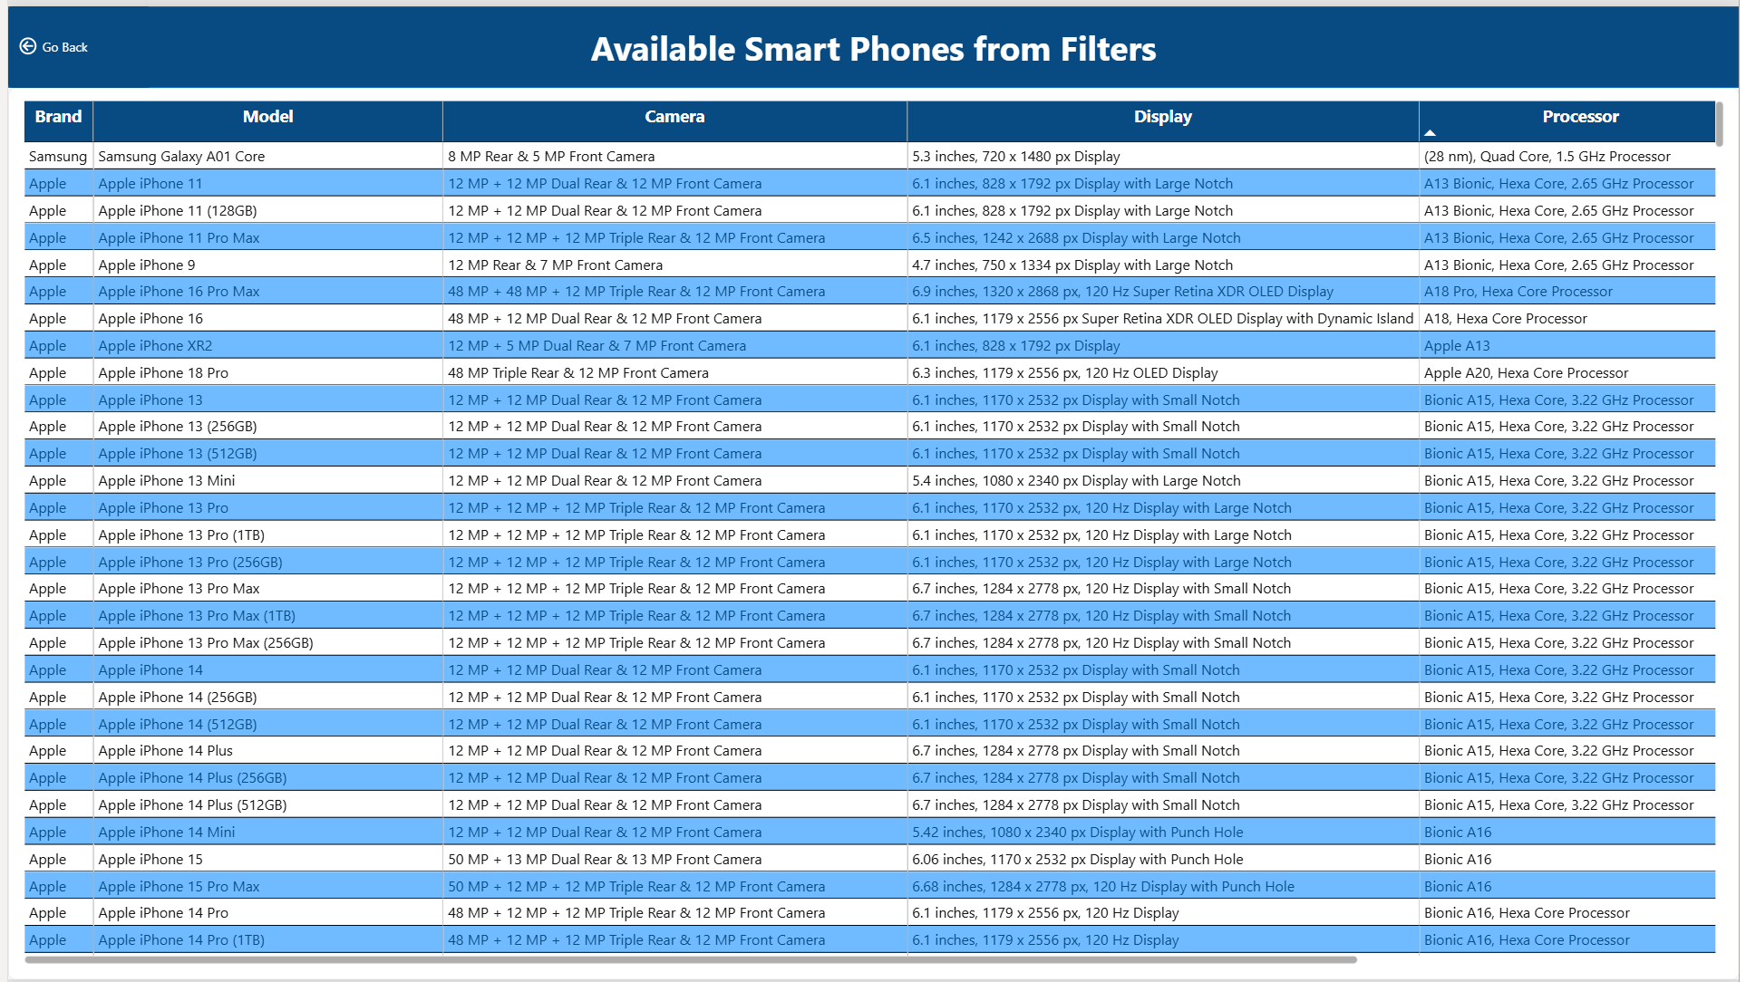
Figure 5.8: Available Smartphones table showing brand, model, camera, display and processor details.

6. FINAL CONCLUSION
SpecScout – Mobile Specification Tracker demonstrates how smartphone specification data can be organised, analysed and presented through an interactive dashboard. The project converts descriptive specification fields into analytical variables such as numeric price, RAM, storage, battery capacity, display size, brand, price segment and operating-system family. The analysis of the 789-record cleaned dataset identifies the leading brands, the dominant price segment, common rating bands and popular memory configurations.
The results show that Samsung, Xiaomi and vivo have the highest model counts in the supplied dataset, while the ₹10,000–₹20,000 entry segment is the largest price group. The most frequent rating range is 80–89, and 128 GB is the most common storage capacity. The dashboard KPI values provide a quick summary of the dataset, while slicers allow users to narrow the phone list by key specifications.
The project can help students, buyers and analysts compare smartphone options more systematically. It does not make a recommendation based on personal preference or real-time stock; instead, it provides a structured view of the specifications and values contained in the dataset.

7. FUTURE OUTCOMES AND LIMITATIONS

7.1 Limitations
- The analysis depends on the accuracy and completeness of the Kaggle dataset and may not represent every smartphone model in the market.
- The exact Kaggle dataset URL and access date were not supplied with the project files.
- The uploaded raw Excel file contains 1,074 rows, while the uploaded cleaned CSV contains 789 rows. The provided cleaning script does not explain the full row reduction.
- The raw file contains missing values in rating, camera, card and operating-system fields, but the uploaded cleaned CSV contains no missing values; the exact handling of all missing values is not documented in the supplied script.
- Extreme prices and battery capacities may affect averages and visual scales. Some values should be checked against the original source before making purchasing decisions.
- The dataset is a snapshot of listed specifications and does not establish current availability, live prices, warranty conditions or user satisfaction.
- The observed price-rating relationship is correlational and cannot establish that price causes a higher rating.

7.2 Future Scope
- Connect the dashboard to a regularly updated dataset so that new smartphone models and price changes can be monitored.
- Add more comparison fields such as charging speed, chipset benchmarks, camera sensor details, software-update policy and launch date.
- Develop a user-driven recommendation feature based on budget and required specifications.
- Add price history and availability information from verified sources.
- Use statistical or machine-learning methods to explore price prediction, rating prediction or smartphone segmentation, with proper validation.
- Publish the dashboard or build a web-based interface so that users can access the comparison tool more easily.

7.3 Expected Outcomes
If the project is extended with verified and regularly updated data, SpecScout could become a more useful comparison tool for identifying smartphones that meet a user's budget and specification requirements. Additional data validation and documented cleaning rules would also improve the reliability and reproducibility of the analysis.

APPENDIX: CODE AND DASHBOARD

A. Project Files
File | Purpose
SpecScout-Dataset-Collection.xlsx | Raw smartphone dataset supplied for the project.
data_cleaning_script.py | Reads the Excel dataset, cleans price formatting and extracts specification values using regular expressions.
SpecScout_Dataset_Fully_Cleaned.csv | Final cleaned dataset used by the supplied analytics and visualisation scripts.
DATA_ANALYTICS (2).py | Performs ten table-based analyses and exports result tables as CSV files.
visualization.py | Creates ten Matplotlib charts and saves them as PNG files.
Power BI dashboard screenshots | Evidence of the interactive overview and filtered smartphone listing pages.

B. Main Code Operations
The data cleaning script uses pandas and regular expressions to convert price text into numeric values and extract hardware capacities. Example:
cleaned_df['price_cleaned'] = pd.to_numeric(
cleaned_df['price'].astype(str).str.replace('₹', '', regex=False).str.replace(',', '', regex=False),
errors='coerce'
)
The analytics script groups smartphone records by brand, price segment, rating band, 5G support, RAM, storage, battery and operating system. It exports the resulting tables to CSV files.
The visualisation script uses Matplotlib to generate bar charts, a scatter plot, a pie chart and histograms, saving the figures as high-resolution PNG files.

C. Dashboard Link
Power BI dashboard file or published dashboard URL: Not supplied. Insert the .pbix file location or published link here if available.
Kaggle dataset URL: Not supplied. Add the exact dataset URL before final submission.
Submitted by: B. Sathwik, T. HariswaraBrahmam and A. Saiteja
Faculty Signature: ______________________________

